C:\Program Files (x86)\Microsoft Office\MEDIA\CAGCAT10\j0301480.wmfC:\Program Files (x86)\Microsoft Office\MEDIA\CAGCAT10\j0301480.wmf

Two 1-Week Basketball Clinics and Games:

July 24th-28th from 12pm - 3pm each day

July 31st- Aug. 4th from 12pm – 3pm

Two 1-Week Volleyball Clinics and Games:

July 10th-14th from 12pm – 3pm

July 17th -21st from 12pm - 3pm each day

We will use outdoor space to work on skills that are universal and transferable to all sports as well. (Hand-eye coordination, throwing, catching, movements, etc.)

2-Weeks of Games, Activities, and More:

August 7th-11th from 12pm – 3pm each day

August 14th-18th from 12pm – 3pm each day

**Cost:  $75 per Week Session/ $425 for all 6 Weeks**

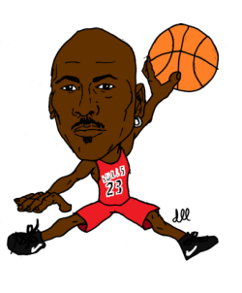**Who:  Incoming 4th-8th Grade Boys and Girls**

**Where: Waters Elementary**

* **Each session has a max of 20 children. Priority will be given to those children signing up for both weeks of the clinic.**
* **Email Mr. Orlov at** [**bmorlov@cps.edu**](mailto:bmorlov@cps.edu) **for any questions.**

**Child’s Name: _________________________________**

**Parent Information**

**Names and Emails: __________________________________________________**

**__________________________________________________**

**Weeks of Interest (Select as many as you would like):**

**All 6 Weeks**

**(July 10th – August 18th) ______**

**Week 1 Volleyball**

**(July 10th – 14th) ______**

**Week 2 Volleyball**

**(July 17th – 21st) ______**

**Week 3 Basketball**

**(July 24th – 28th) ______**

**Week 4 Basketball**

**(July 31st – Aug. 4th) ______**

**Week 5 Fun and Games**

**(August 7th – 11th) ______**

**Week 6 Fun and Games**

**(August 14th – 18th) ______**

***\*Please return to Mr. Orlov or the office as soon as possible.***