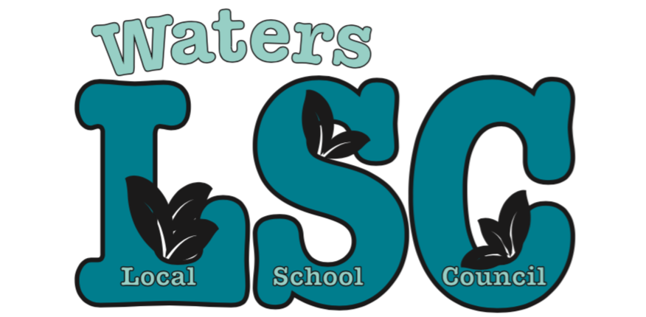

Notice is hereby given that a regularly scheduled
Local School Council meeting has been set for

Tuesday June 11, 2019–6:30 pm to 8:00 pm
Waters Elementary School
4540 N Campbell Ave

Agenda:

- Call meeting to order
- Roll call
- Motion to approve agenda
- Motion to approve minutes from previous meeting(s)
- Special Presentations:
Nature Play Space - Alison MacDonald Ryan (15 min)
- Reports
- Principal Report (10 min)
- BAC (5 min)
- Budget (10 min)
- CIWP (5 min)
- Principal Evaluation (5 min)
- PPLC (5 min)
- Facilities and Grounds (5 min)

- Public comment (2 min per person). Please note: This period is dedicated for questions/comments that directly pertain to the 3 functions of the LSC: Budget, CIWP, and Principal Evaluation. Other questions/comments will be directed to administration (general school operations), teachers (specific classroom/grade level questions), or WatersToday (fundraising and volunteering).
- Old business

- New business

- Organizational Meeting July

b. Motion to approve expenditures over $1000:

Check 2405 Broadway In Chicago (Hamilton Exhibit) $3611.00
Check 2406 BJ’s Transportation (transportation to HE) $1100.00
Check 2412 Interstate Studio (Yearbook) $3557.00
Check 2415 Bluestar Embroidery (Kdg T’s and Caps) $1892.00
Check 2416 Scholastic Book Fair (Spring) $6361.30

- Motion to go into executive session for Principal Evaluation follow-up
- Adjournment

