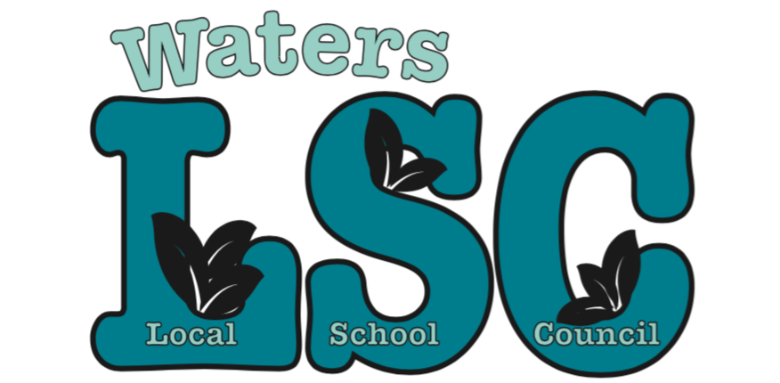

Notice is herby given that a regularly scheduled
Local School Council meeting has been set for

Tuesday March 19, 2019
4:00 PM-5:30 PM, Waters School

Agenda:

- Call meeting to order
- Roll call
- Motion to approve agenda
- Motion to approve minutes from previous meeting(s)
- Special Presentations:
  - Student Presentation: Youth Climate Strike IL
  - ILT Presentation
- Reports:
- Principal Report (10 min)
- BAC (5 min)
- Budget (5 min)
- CIWP (5 min)
- Principal Evaluation (5 min)
- Facilities and Grounds (5 min)
- PPLC (5 min)

- Public comment (2 min per person). Please note: This period is dedicated for questions/comments that directly pertain to the 3 functions of the LSC: Budget, CIWP, and Principal Evaluation. Other questions/comments can be directed to administration (general school operations), teachers (specific classroom/grade level questions), or WatersToday (fundraising and volunteering).

- Old business
- New business
- Motion to approve executive session for Principal Evaluation
- Adjournment

