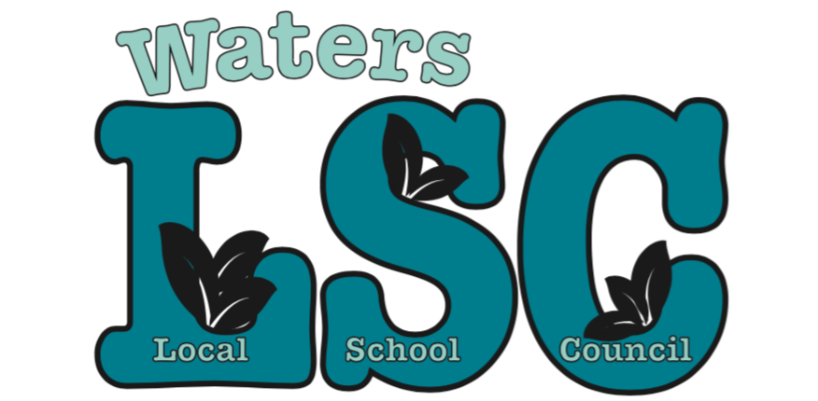

Notice is herby given that a regularly scheduled
Local School Council meeting has been set for

Tuesday January 15, 2019
3:30 PM Executive Session
4:00 PM-5:30 PM Public Meeting
Waters Digital Media Room

Agenda:

- Call meeting to order
- Roll call
- Motion to approve executive session
- Motion to approve agenda
- Motion to approve minutes from previous meeting(s)
- Special Presentations:
  - 15-week monitoring report on 2018-2020 CIWP by ILT (30 min)

- Reports
- Principal Report (10 min)
- BAC (5 min)
- Budget (5 min)
- CIWP (5 min)
- Principal Evaluation (5 min)
- PPLC (5 min)

- Public comment (2 min per person). Please note: This period is dedicated for questions/comments that directly pertain to the 3 functions of the LSC: Budget, CIWP, and Principal Evaluation. Other questions/comments can be directed to administration (general school operations), teachers (specific classroom/grade level questions), or WatersToday (fundraising and volunteering).

- Old business
- New business:
  - Motion to Approve Expenditures >$1000 (Scholastic Book Fair $8949.76)

- Adjournment

