**Seventh Grade**

Reading

**2018-2019**

This Year in Reading Class

This year in reading, we will be exploring and analyzing a wide variety of genres in literature, expanding our vocabulary and respond in writing to what we have read. We will engage in rich academic conversations as well as learn about the art of formal argument. We will be applying the Common Core Standards for Language Arts as we put these practices in action. Students will read literature from not only the classroom textbook, but from novels, non-fiction literature, articles and other primary sources. Book studies, literature groups and independent reading will be common practices in class.



What do you need to bring daily to reading class?

* Your reading notebook.
* Pens
* Pencils
* Reading Selection we are currently working on.
* Color Pencils
* Sticky Notes
* Highlighters
* Completed Work
* Positive Attitude

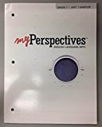

Literature Textbook:

We will be using ***myPerspectives*** (Grade 7)

published by Pearson. Students have been given

their own consumable paperback textbook as well

as an online access through pearsonrealize.com

**Effective Expression**: Writing to Sources/Speaking/Listening

**Areas of Study**

Many of the skills we learn in Language Arts will be applied throughout the year. Some highlights of our learning this year will include:

Story Elements Literary Devices Analyzing Text Close Reading Analyzing Argument Objective Summary Making Predictions Making Inferences Author’s Purpose Main Idea Fact & Opinion Point of View Morpheme Study Comparing and Contrasting **Themes**

**As part of our new series, we will be exploring five themes:**

* Generations: In what situations can one generation learn from another?
* A Starry Home: Should we spend valuable resources on space exploration?
* Turning Points: What can cause a significant change in one’s life?
* People and the Planet: Are the needs of people ever more important than the needs of animals on this planet?
* Facing Adversity: How can people overcome adversity in the face of overwhelming obstacles?

***Read…Read… Read!!***

*All CPS students are expected to read 25 books throughout the school year. Please make sure you are reading daily for 20 or more minutes. Great times to read: in the car, on the bus, when waiting for something, or just curl up with a good book at bedtime.*

C:\Program Files (x86)\Microsoft Office\MEDIA\CAGCAT10\j0158007.wmf

# *“The best moments in reading are when you come across something - a thought, a feeling, a way of looking at things - which you had thought special and particular to you. And now, here it is, set down by someone else, a person you have never met, someone even who is long dead. And it is as if a hand has come out, and taken yours” - Alan Bennett*

Grading Scale

A = 90-100

B = 80-89

C = 70-79

D = 60-69

F = 59 & below

Grading Weights

40% Summative

25% Formative

25% Classroom Activities

10% Homework & Practice

Homework Policy

Students will receive out of class work on a regular basis. This may be homework or projects. Homework will consist of reading, bookwork or other reinforcement type activities. The following is the Waters School homework policy:

“The purpose of homework is two-fold: to reinforce what we have learned in class and to teach responsibility.  A child who has done his/her homework is prepared in class to hear explanations of what he/she might have had trouble with at home.  If an unusual circumstance prevents your child from doing his/her homework (sickness, injury, or other serious problems), we ask that you please send a note with your child in the morning so that he/she can be excused and have an opportunity to make it up.”

Assignments turned in late (other than due to circumstances mentioned in school policy) will receive partial credit. Late work will not be accepted the last week of the quarter.

C:\Users\family computer\AppData\Local\Microsoft\Windows\Temporary Internet Files\Content.IE5\D7D92I8G\MC900335624[1].wmf

Classroom Expectations

The Reading classroom is an environment where all students belong and their ideas are respected. Students are expected to obey school policies, follow classroom procedures and respect others. Any student who disrupts the learning of others, or their own, will receive consequences. These may include parental contact, detention or other consequences based on the CPS Uniform Discipline Code. For minor classroom disruptions, I use a three strike warning system. On the third strike, I will either meet with the student following class and/or contact home.

**How do Waters Wildcats R.O.A.R. in Reading Class?**

**Responsible:**

We complete all assignments.

We come prepared to work.

We take care of all reading materials. We participate in all activities. **Organized:**

We write down all assignments and keep track of our work.

We turn in our work on time.

We follow directions.

We take good notes.

**Accountable:**

We can share what we learned. We set goals.

We fix our mistakes.

We own up to our actions.

**Respectful:**

We respect others thoughts, ideas and views.

We respect our class time.

We respect the work of others.

We respect the teacher and school staff

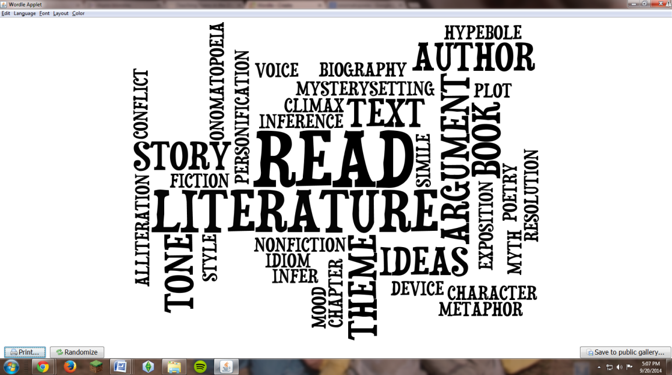

Teacher Information:

**Ms. Regina Cavey, M.Ed.**

Email: rcavey@cps.edu